The images below are from publicly available sources on the internet. The researcher explicitly chose these emails as examples of phishing emails with fake image attachments to create a simulated dataset.

**Simulated Test-1:** Fake Invoice Image-1 (Miami University, 2022)

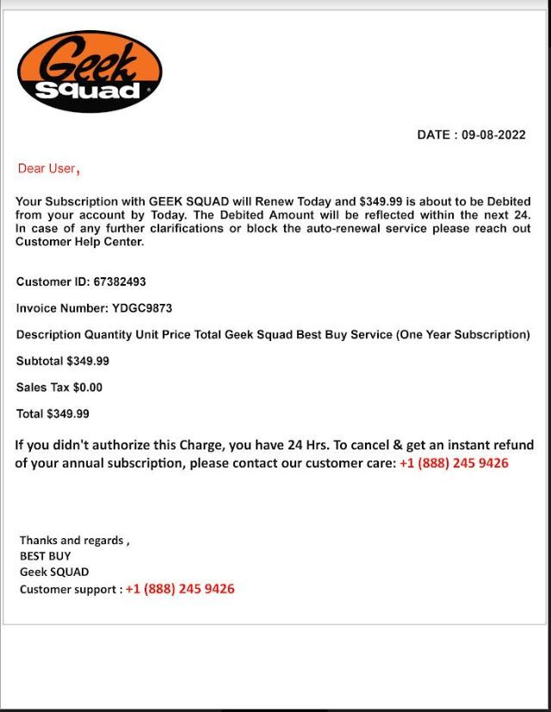

**Simulated Test-1 results:** The script extracted text from Fake Invoice Image-1 and removed the phishing email.

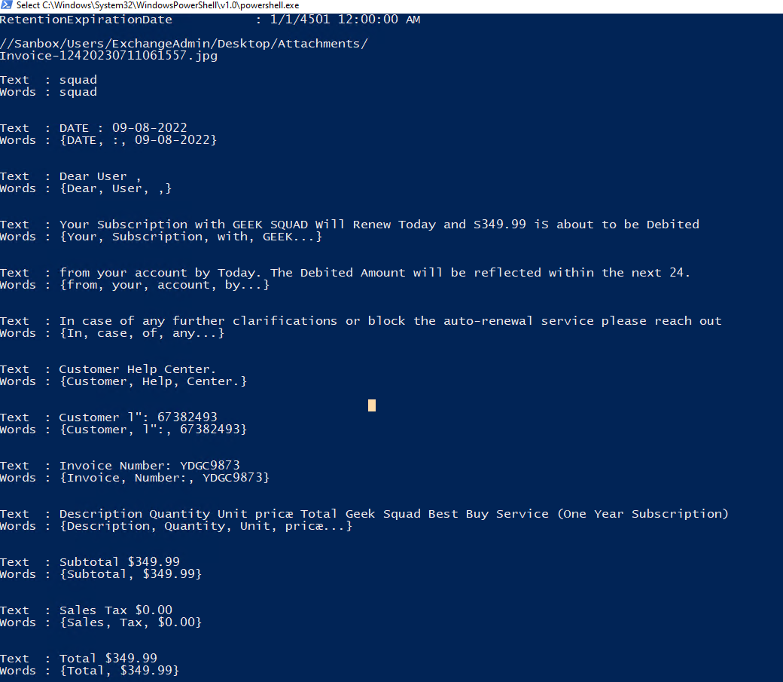

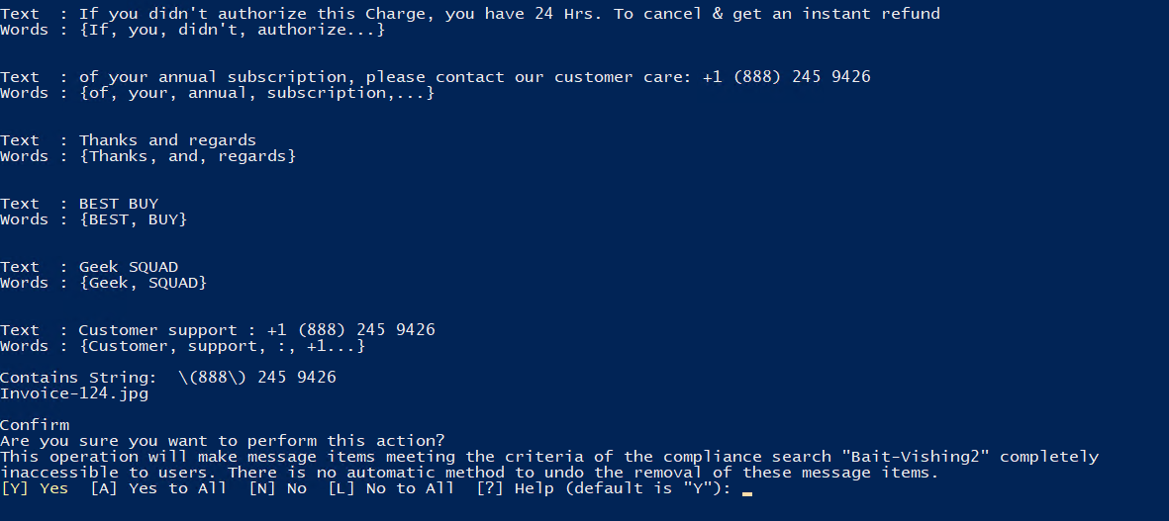

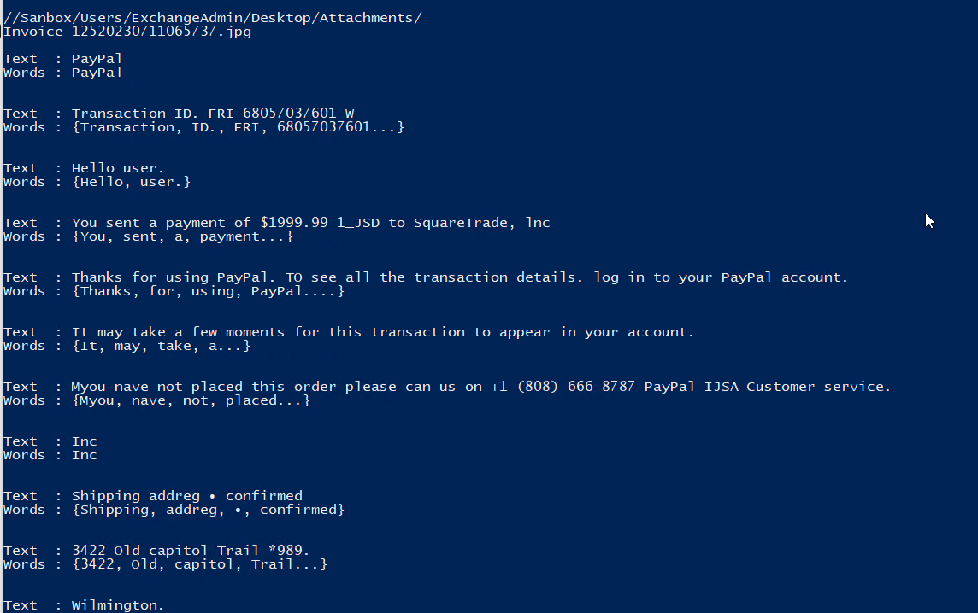

**Simulated Test-2:** Fake Invoice Image-2 (Dedenok, 2021)

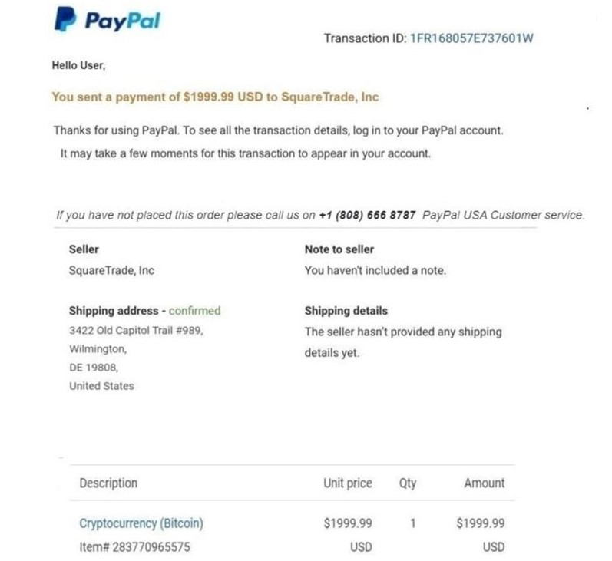

**Simulated Test-2 results:** The script extracted text from Fake Invoice Image-2 and removed the phishing email.



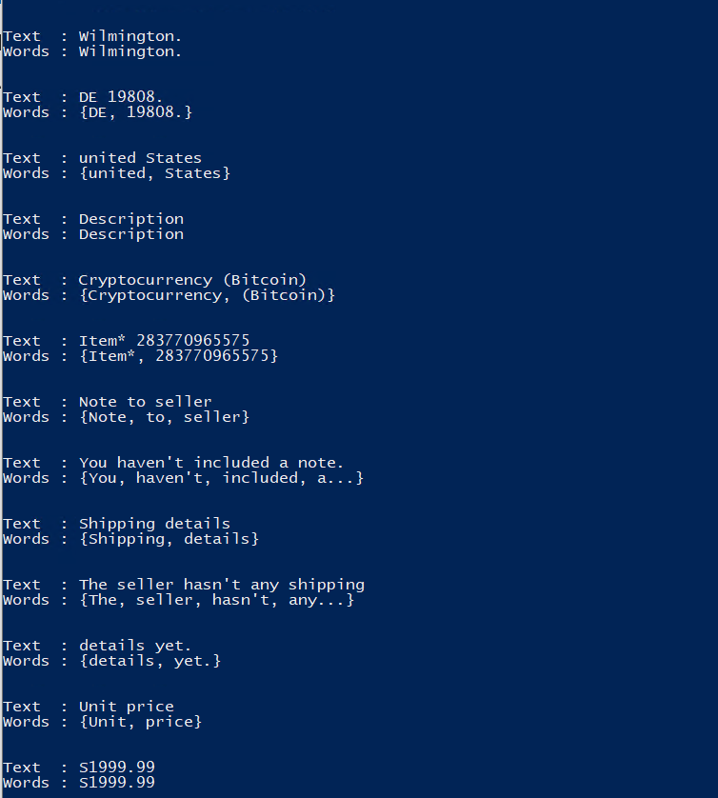

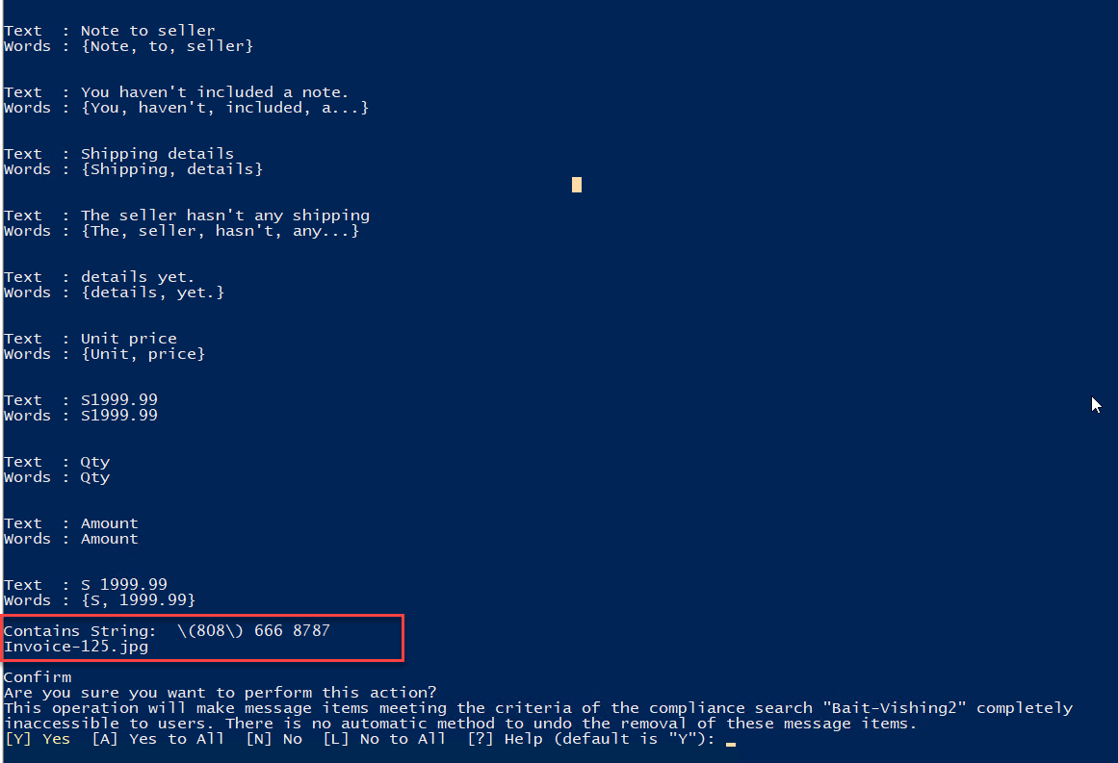

**Simulated Test-3:** Fake Invoice Image-3 (Best Buy, n.d.)

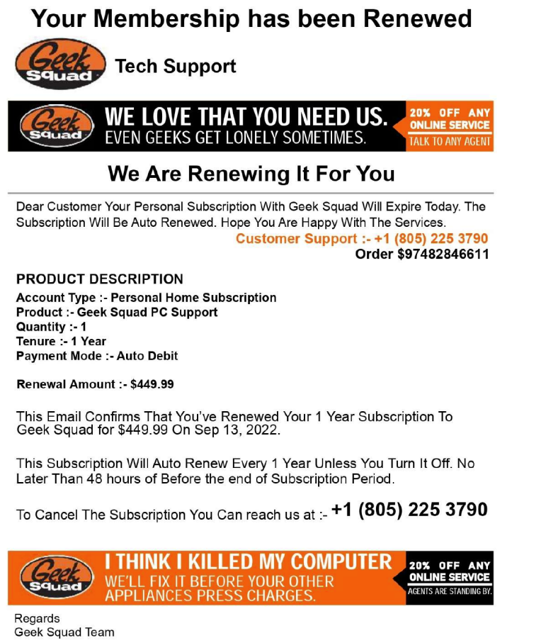

**Simulated Test-3 results:** The script extracted text from Fake Invoice Image-3 and removed the phishing email.

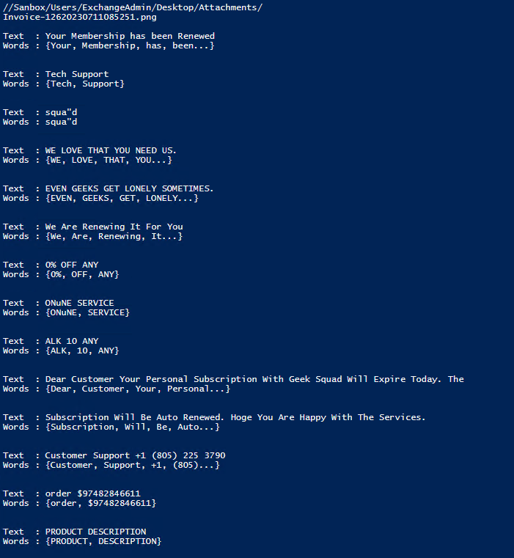

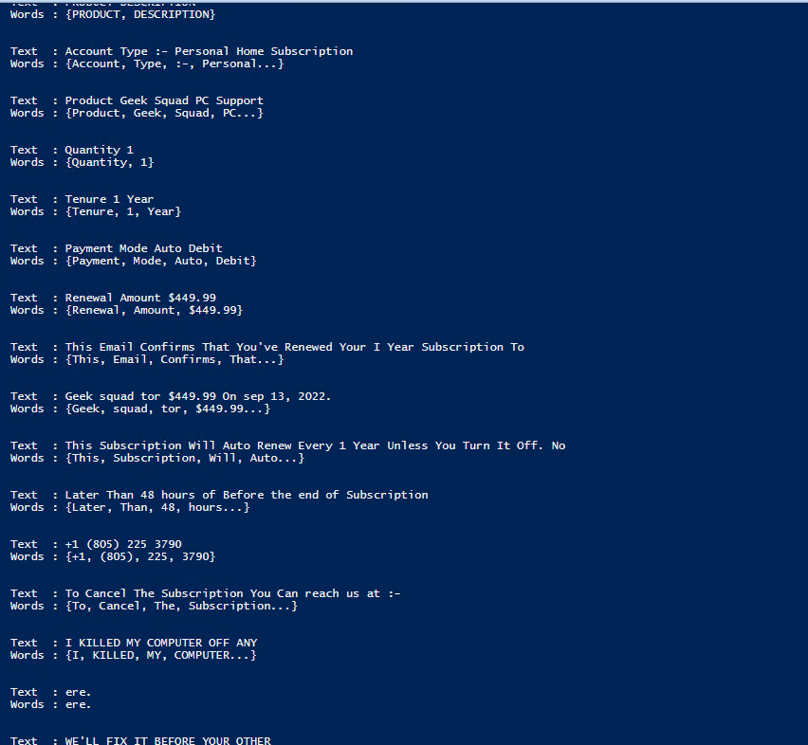

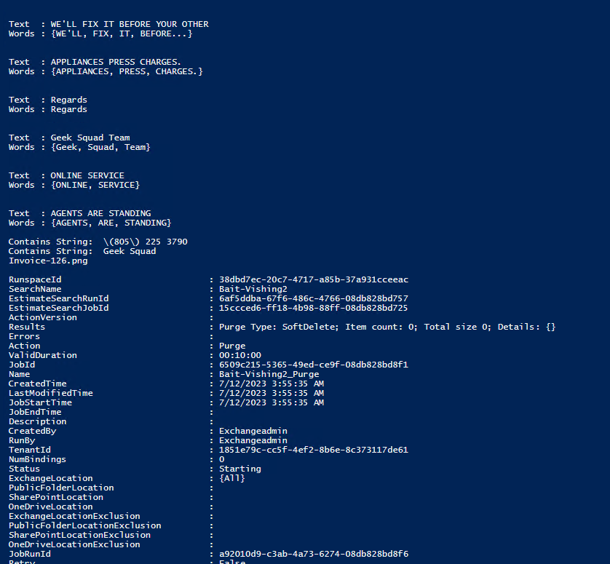

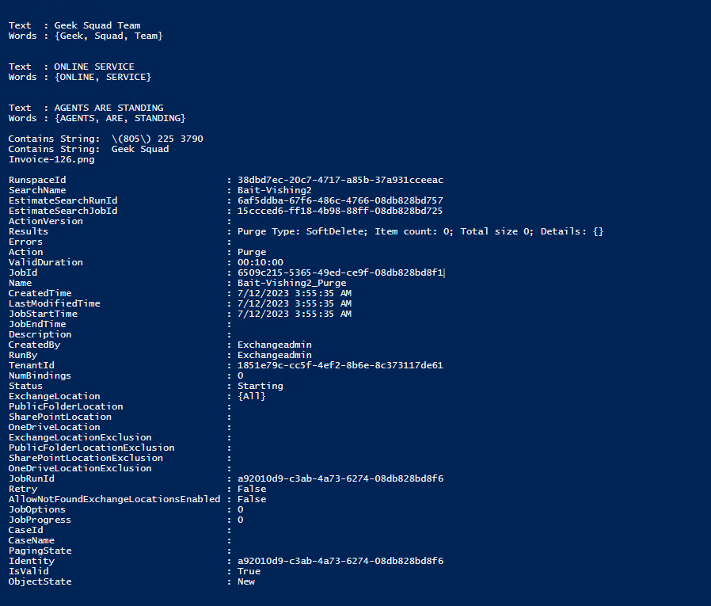

**Simulated Test-4:** Fake Invoice Image-4 (Chhay, 2022)

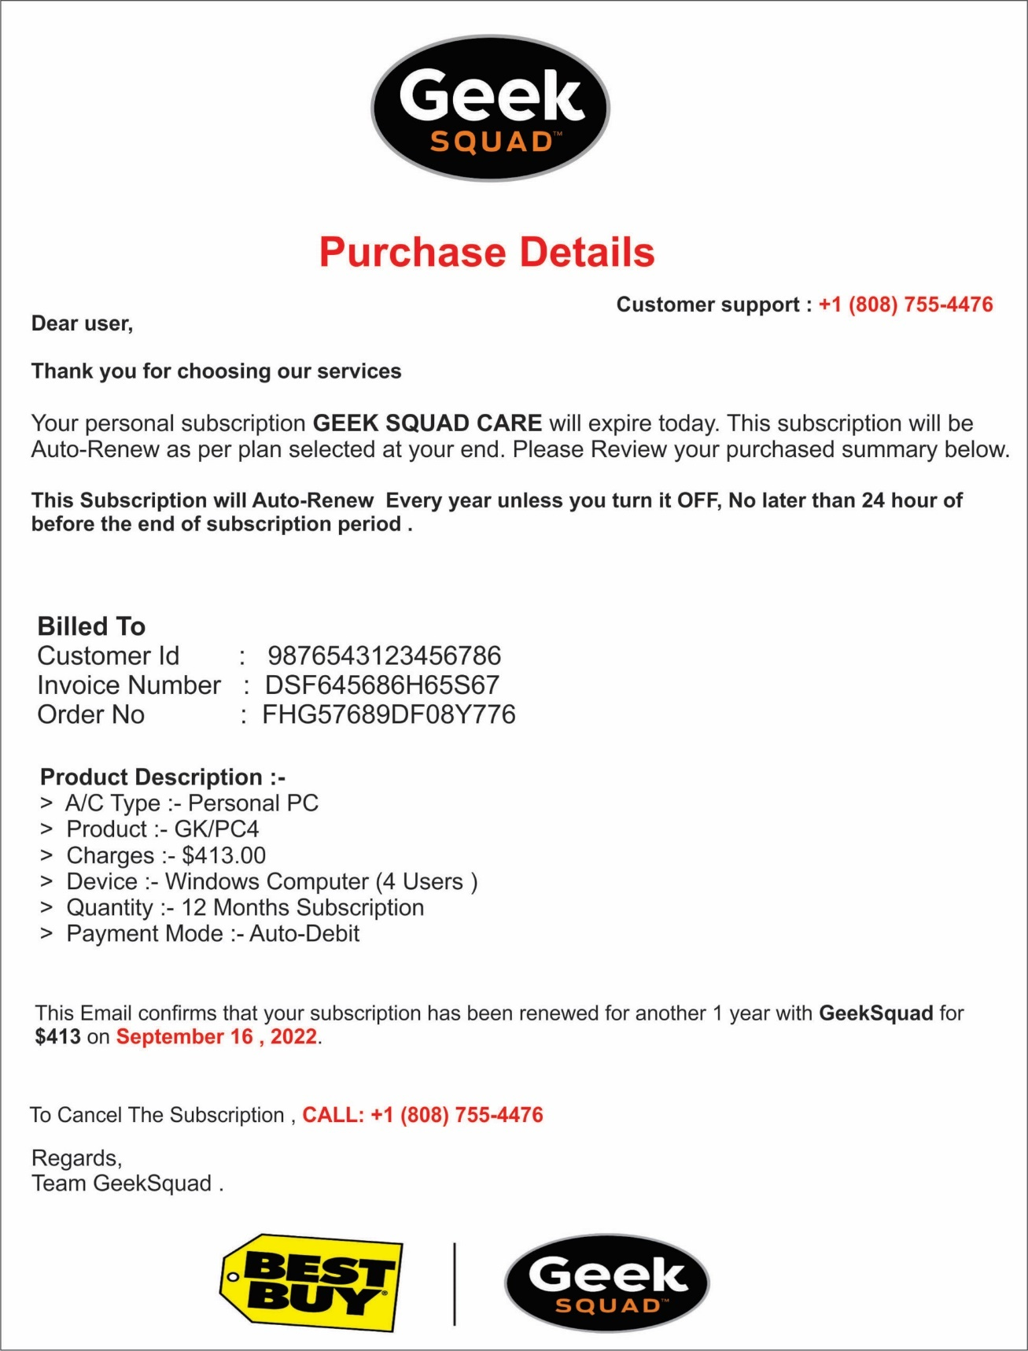

**Simulated Test-4 results:** The script extracted text from Fake Invoice Image-4 and removed the phishing email.

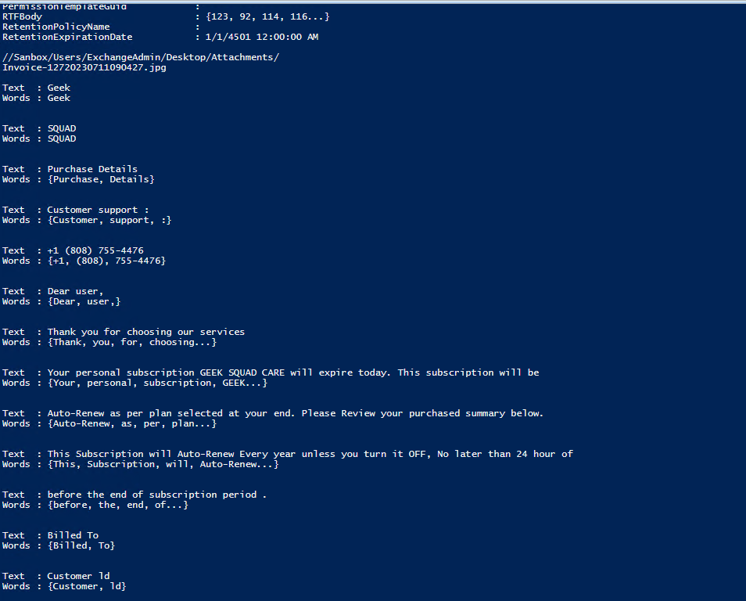

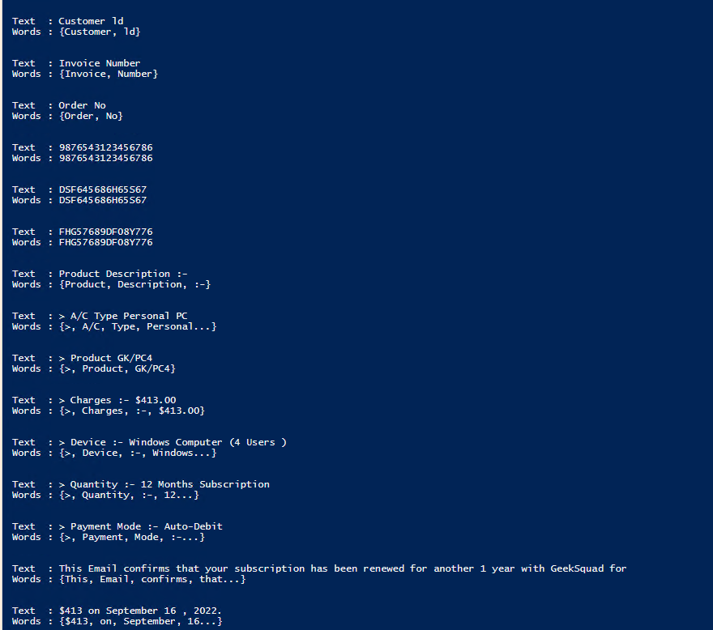

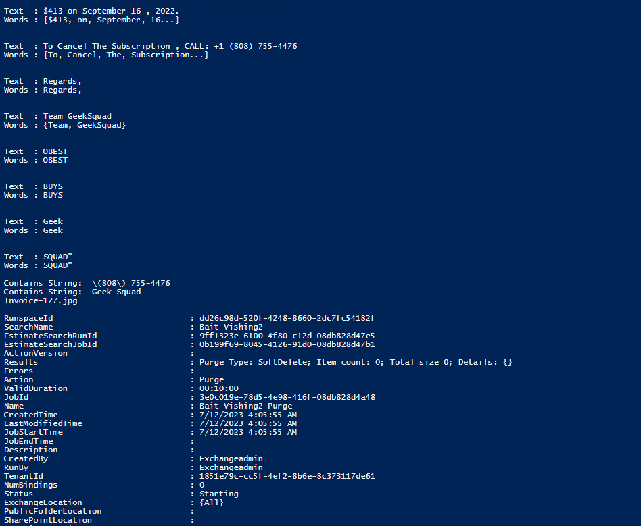

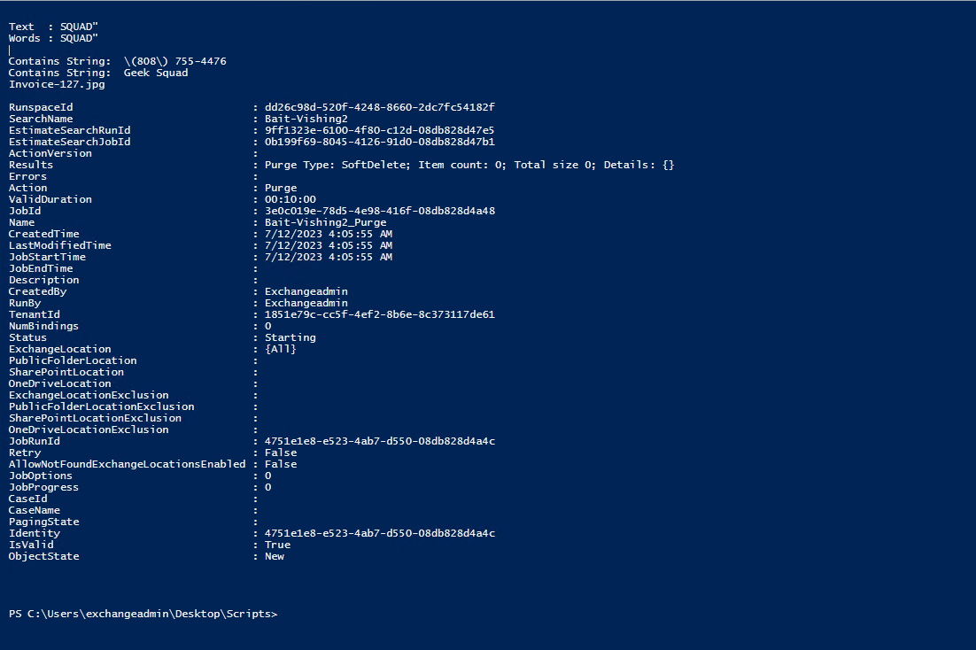

**Simulated Test-5:** Fake Invoice Image-5 (Chhay, 2022)

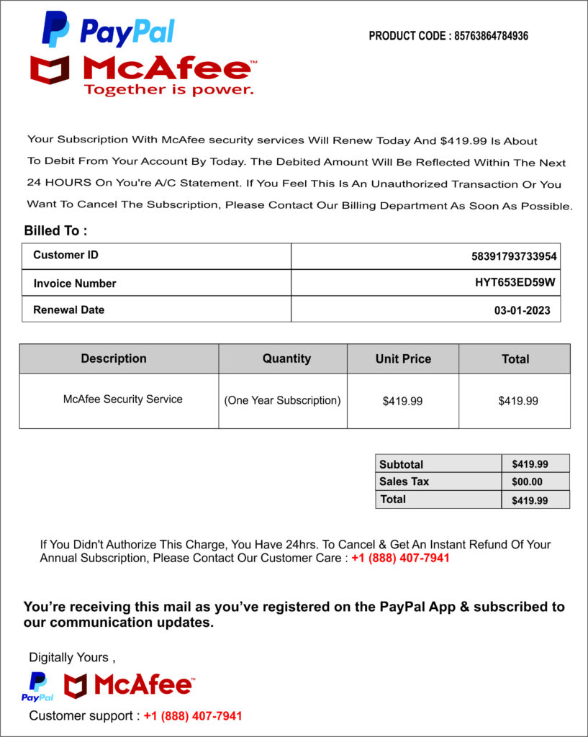

**Simulated Test-5 results:** The script extracted text from Fake Invoice Image-5 and removed the phishing email.

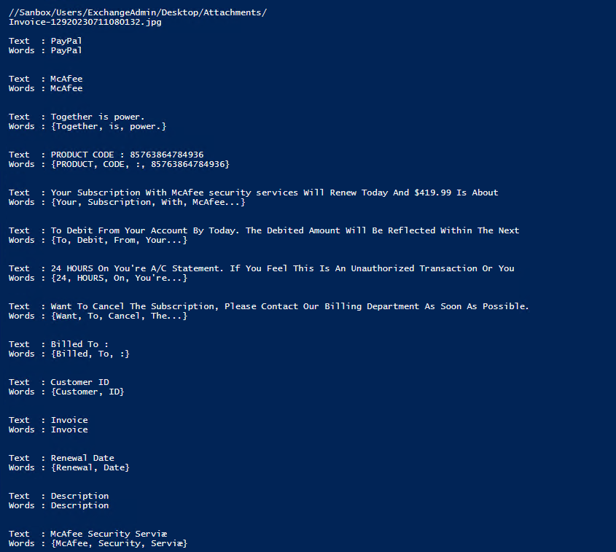

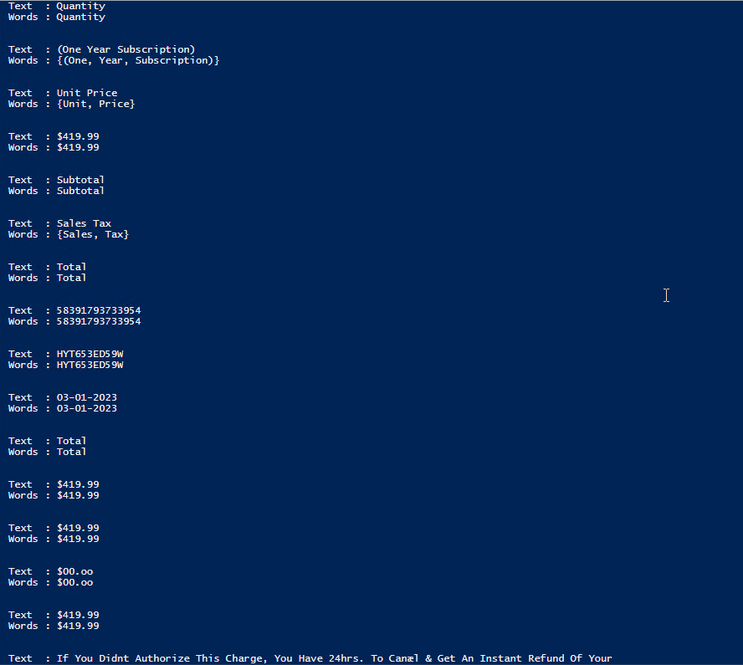

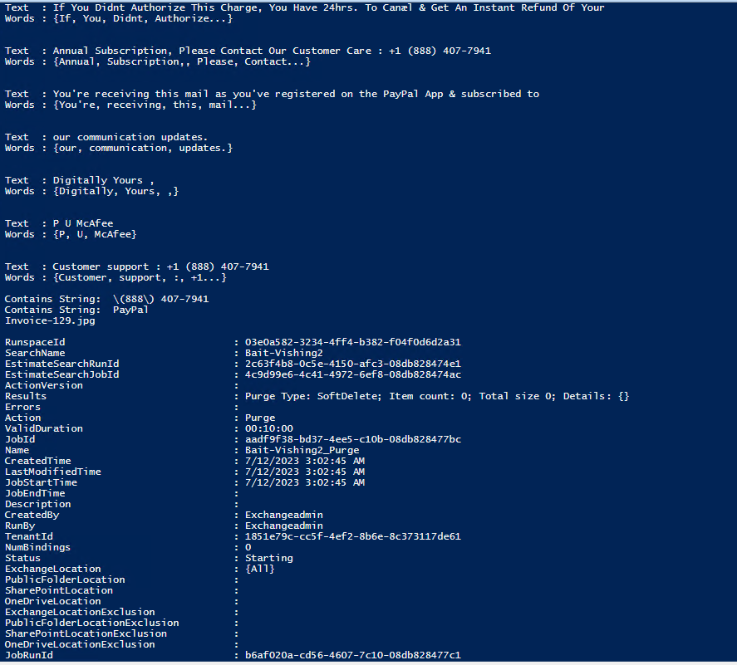

**Simulated Test-6:** Fake Invoice Image-6 (Brown University, 2022)

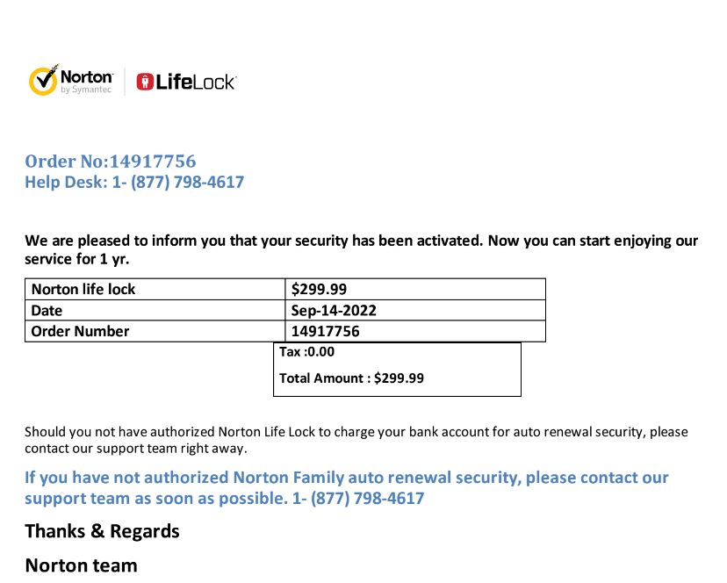

**Simulated Test-6 results:** The script extracted text from Fake Invoice Image-6 and removed the phishing email.

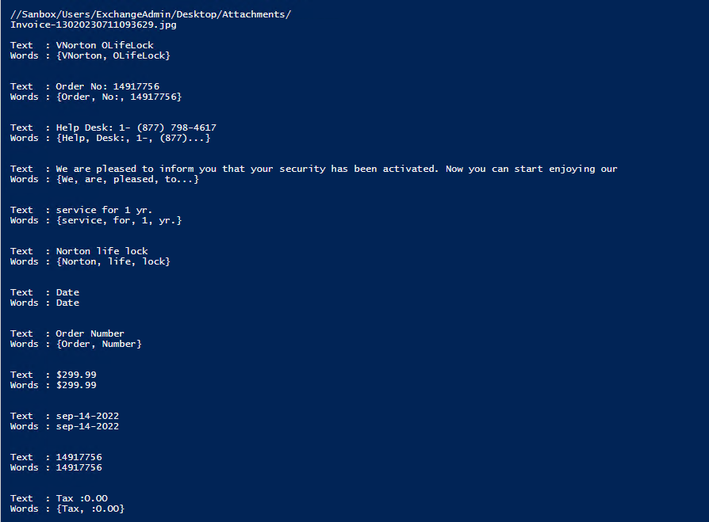

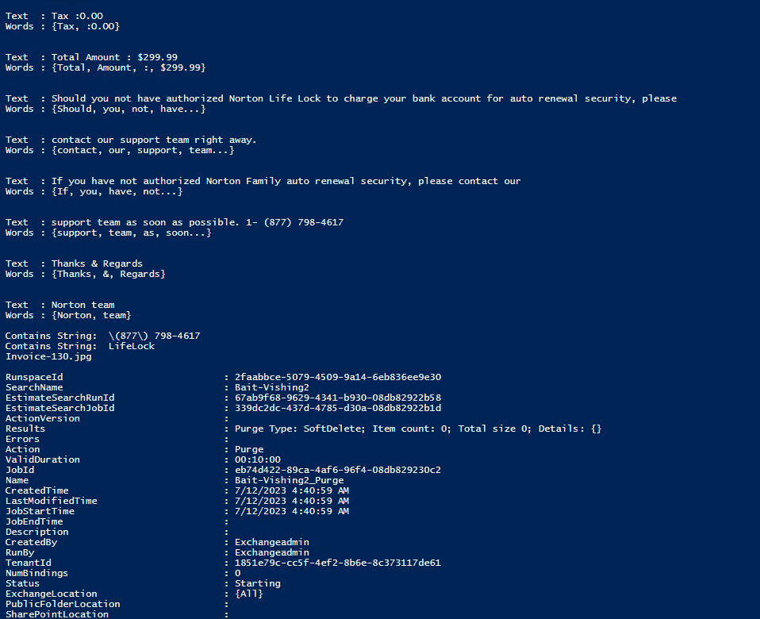

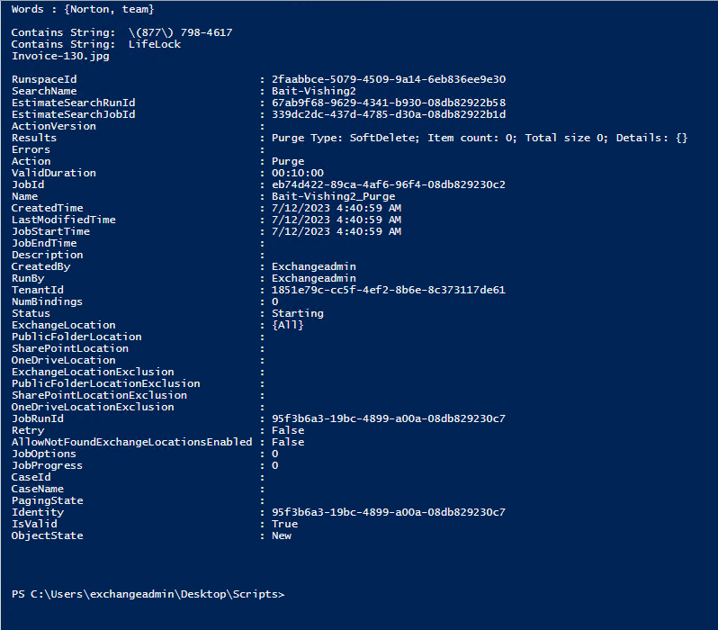

**Simulated Test-7:** Fake Invoice Image-7 (Krebs, 2022)

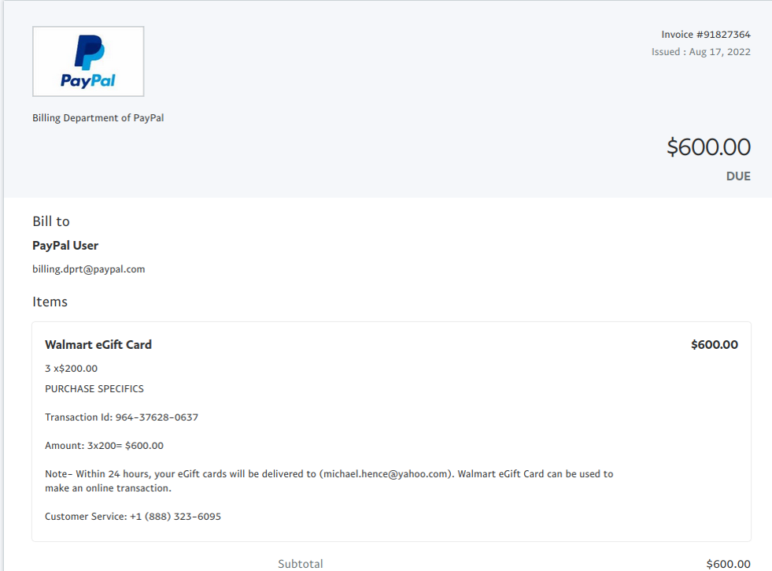

**Simulated Test-7 results:** The script extracted text from Fake Invoice Image-7 and removed the phishing email.

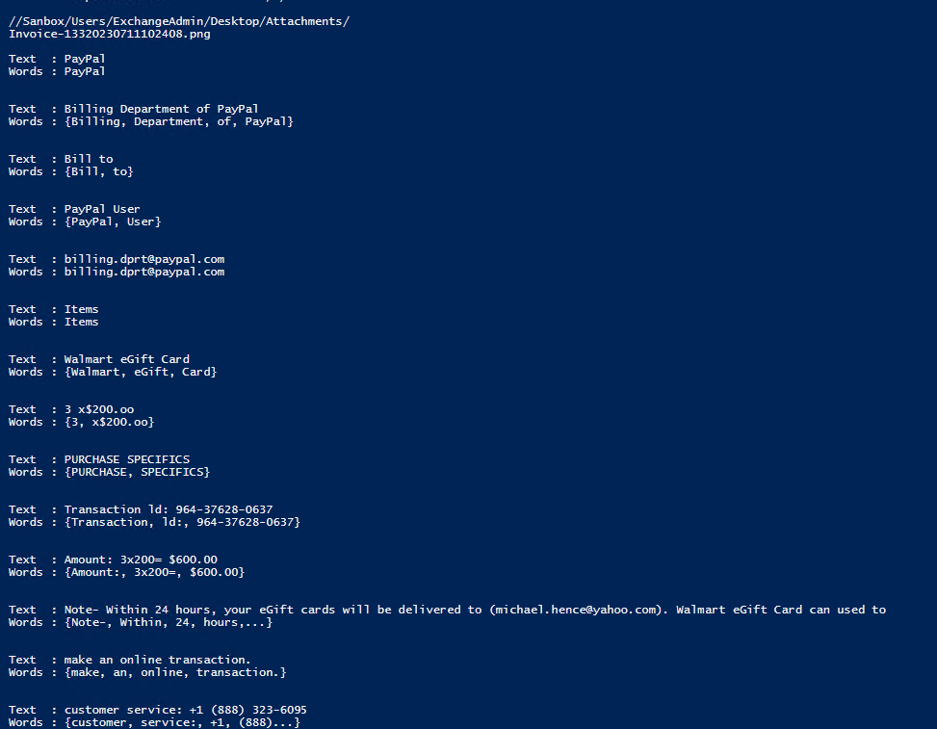

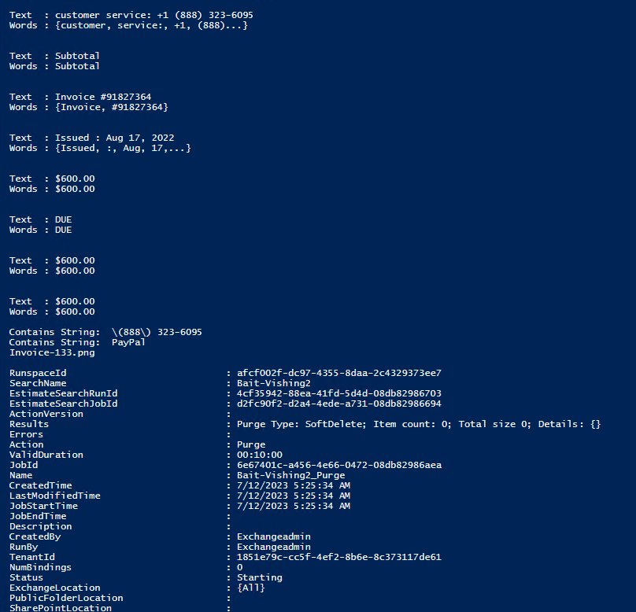

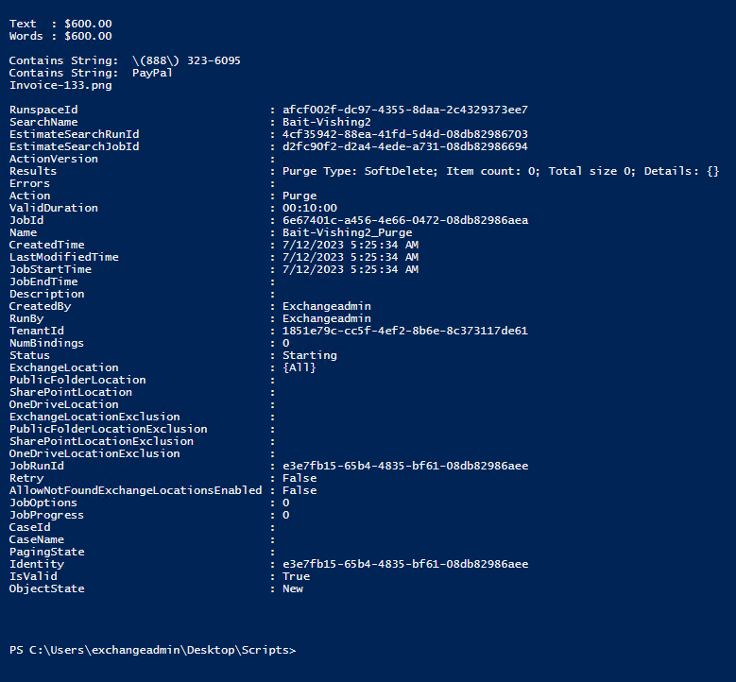

**Simulated Test-8:** Fake Invoice Image-8 (The image was collected from a live phishing email.)

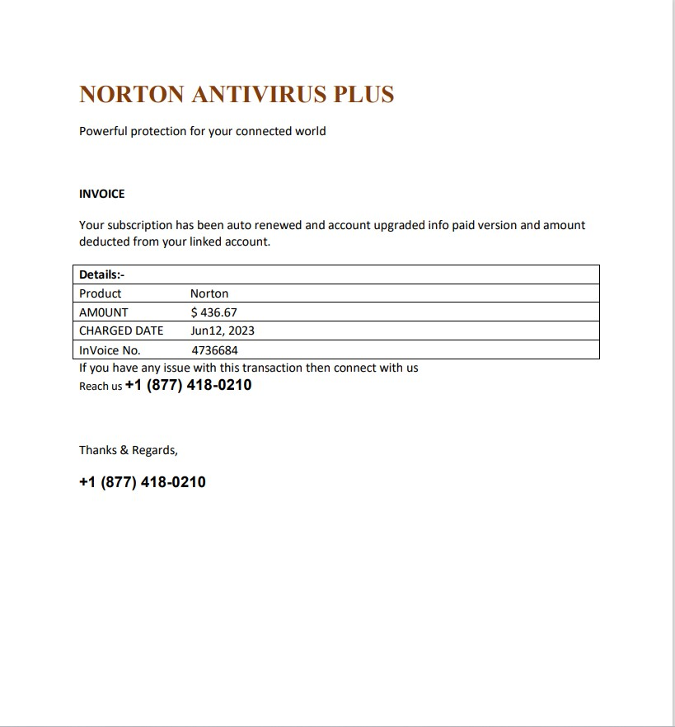

**Simulated Test-8 results:** The script extracted text from Fake Invoice Image-8 and removed the phishing email.

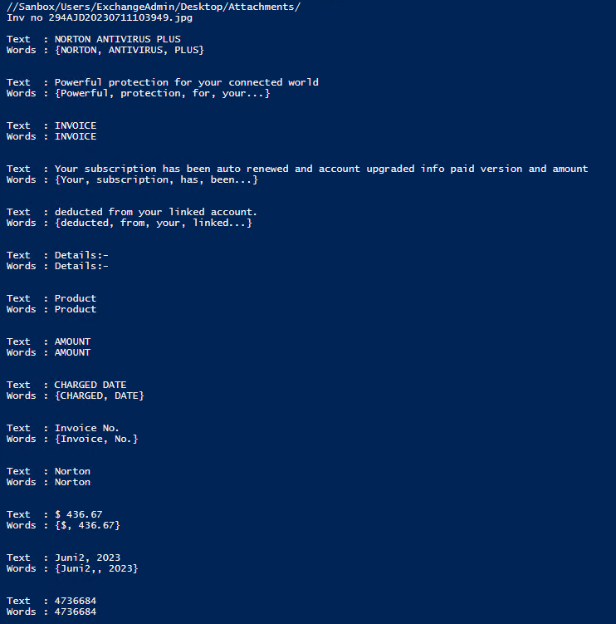

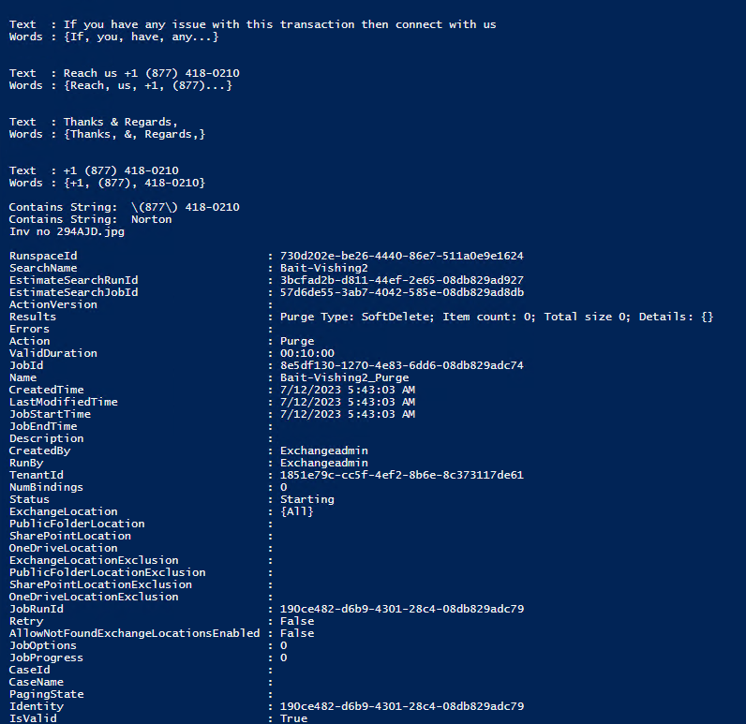

**Simulated Test-9:** Fake Invoice Image-9 (The image was collected from a live phishing email.)

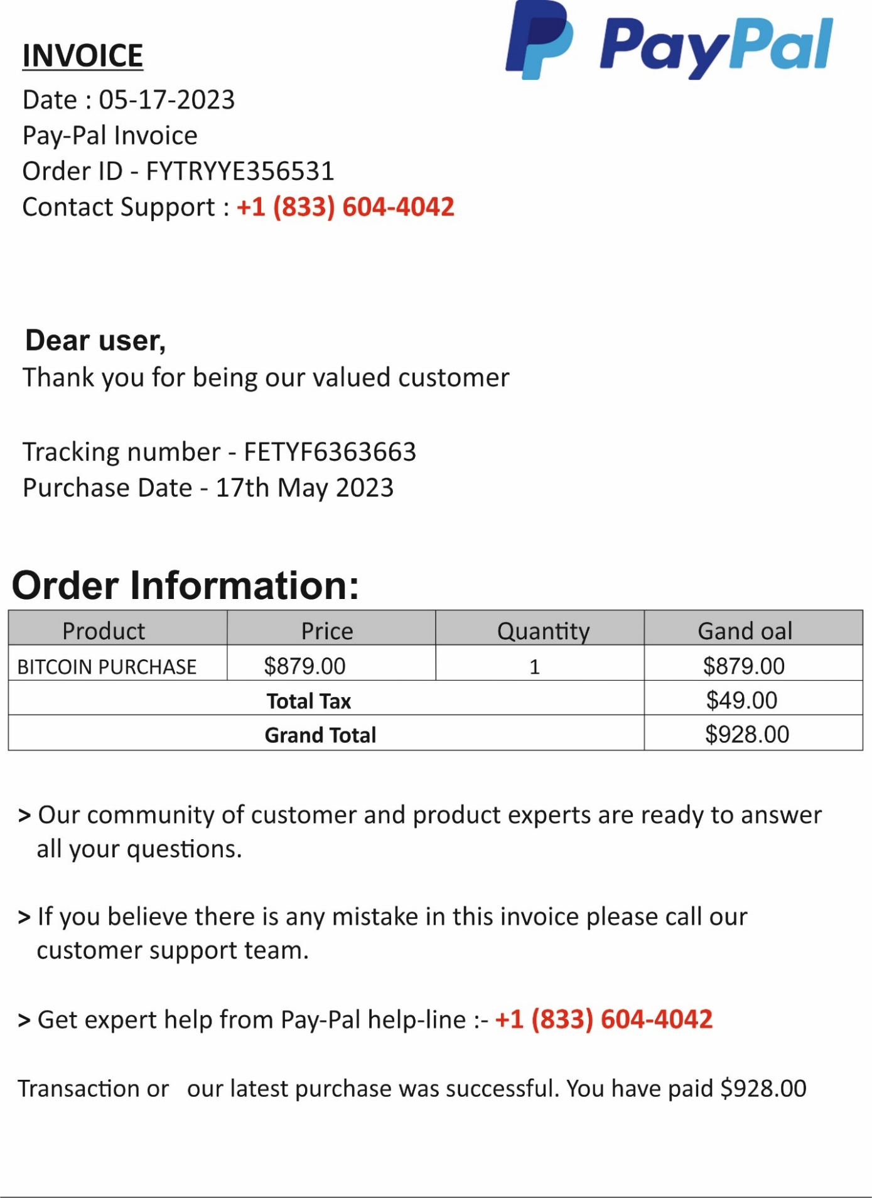

**Simulated Test-9 results:** The script extracted text from Fake Invoice Image-9 and removed the phishing email.

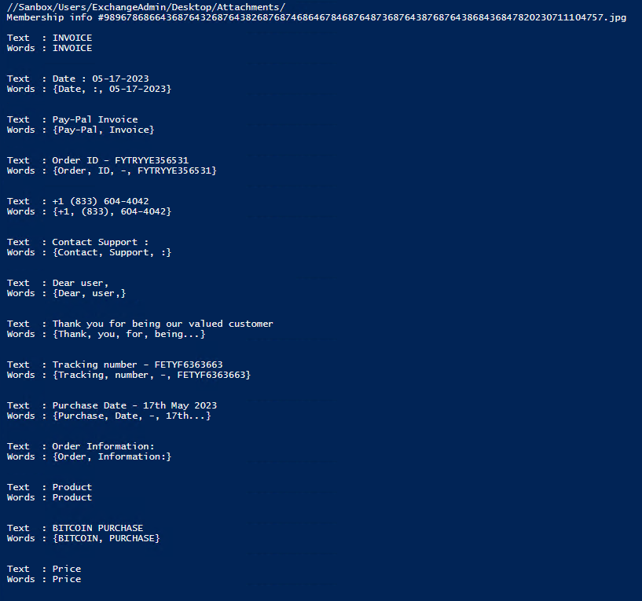

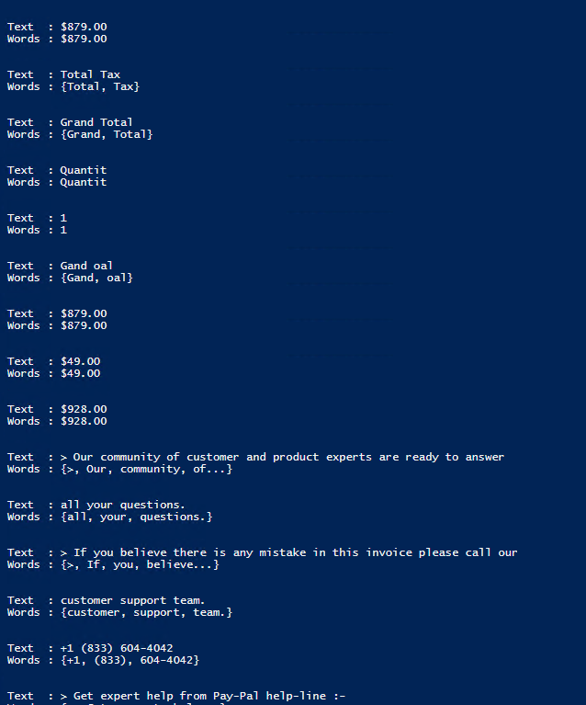

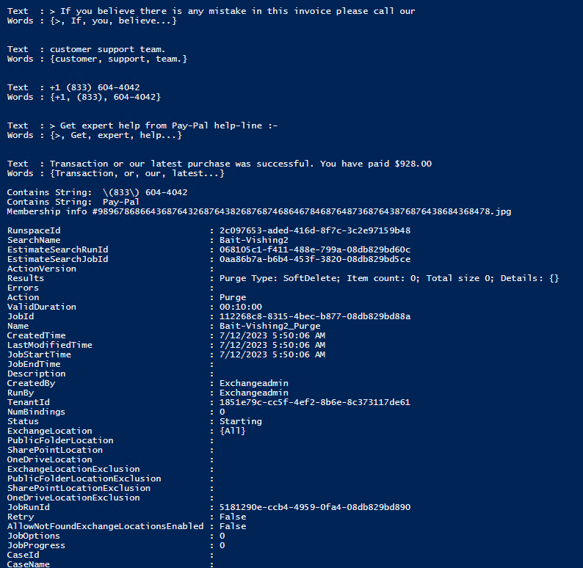

**Simulated Test-10:** Fake Invoice Image-10 (The image was collected from a live phishing email.)

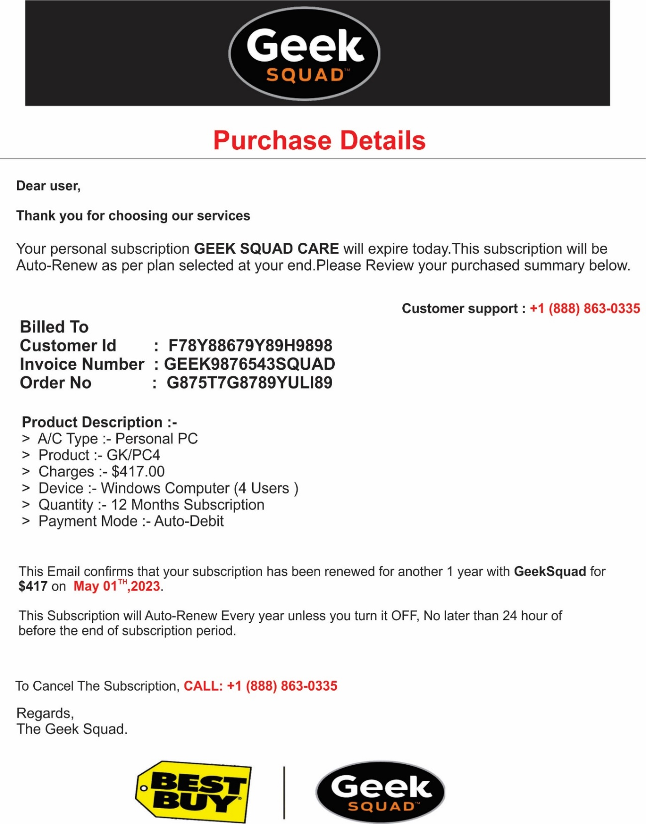

**Simulated Test-10 results:** The script extracted text from Fake Invoice Image-10 and removed the phishing email.

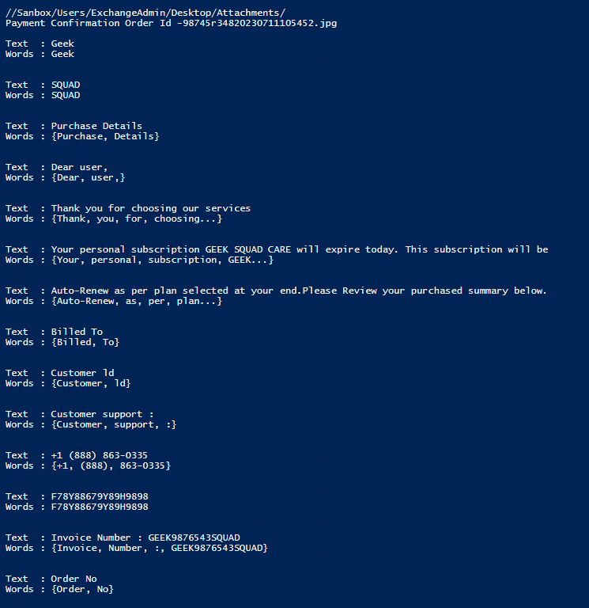

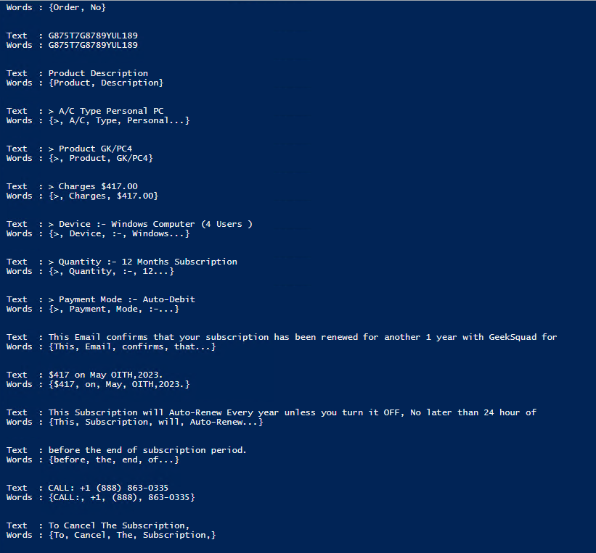

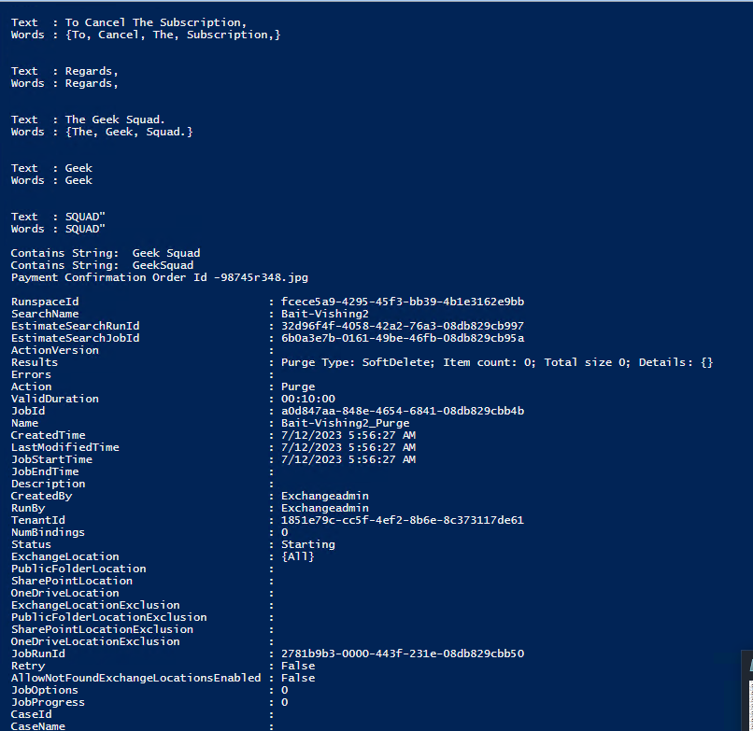

Reference

Best Buy. (n.d., n.d. n.d.). *Learn how to protect yourself and your loved ones against cybercrime and fraud scams.* Retrieved from Best Buy: https://www.bestbuy.com/site/privacy-policy/protect-yourself/pcmcat266100050002.c?id=pcmcat266100050002

Brown University. (2022, September 15). *Norton fake invoices*. Retrieved from Office of Information Technology: https://it.brown.edu/phish-bowl-alerts/norton-fake-invoices

Chhay, A. (2022, September 26). *Fake Invoice Phishing Scams*. Retrieved from Berkleley Lab: https://it.lbl.gov/fake-invoice-phishing-scams/

Dedenok, R. (2021, August 21). *Spam mail with vishing numbers*. Retrieved from Kaspersky Daily: https://www.kaspersky.co.in/blog/spam-with-vishing-phone-numbers/23140/

Krebs, B. (2022, August 12). *PayPal Phishing Scam Uses Invoices Sent Via PayPal*. Retrieved from KrebsonSecurity: https://krebsonsecurity.com/2022/08/paypal-phishing-scam-uses-invoices-sent-via-paypal/

Miami University. (2022, September 9). *Latest phishing scam impersonates Geek Squad.* Retrieved from Miami University: https://miamioh.edu/_files/images/it-services/news-articles/2022/09/geek-squad-scam.jpg